**KEY FINDINGS**

**Primary accident factors**

The vehicle type being the root node of the tree, is the most significant factor. In this case lorries cause moderate injuries.

If not the lorries, weather conditions such as foggy weather play a significant role.

Location such as Uhuru highway is harzadous.

And lastly, time of accident influences whether the injuries are fatal or not. For example, accidents on Uhuru highway are likely to be fatal in the afternoons.

**Weather and road conditions impacts**

From the decision tree, foggy weather increases the risks of moderate injuries while the road conditions (wet, dry) were not included in the tree meaning they were not found as a significant factor to cause injuries.

**Accident Hotspots**

Uhuru Highway in the afternoons was found to be the highest location with fatal accidents.

**Vehicle involvment trends**

Lorries were found to cause moderate injuries with no other factors, while for the other vehicles led to severe or fatal accidents depending on the weather and location.

**Accident dataset in arff format** 

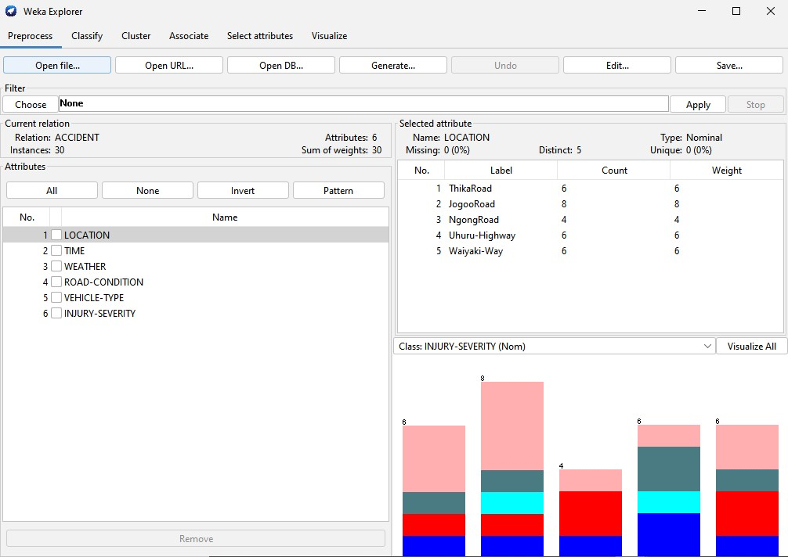

**Decission tree in J48 using training set**

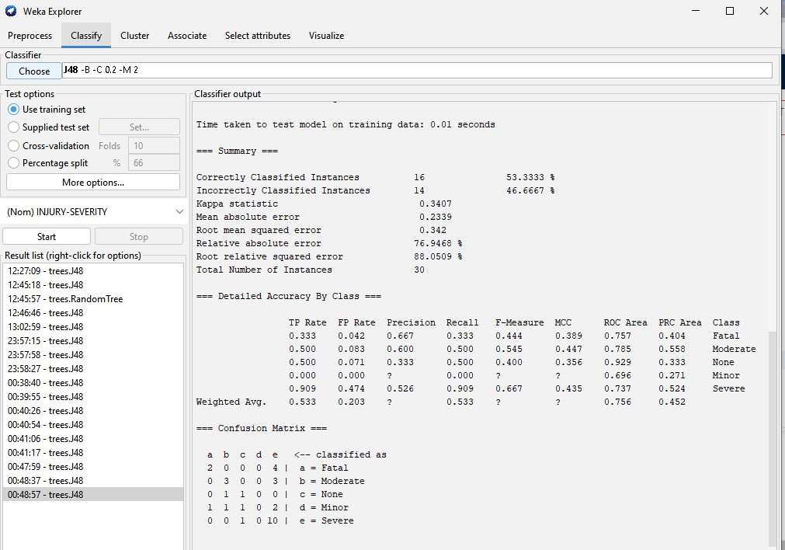

**Visual tree** 